|  |
| --- |
| Date : 13/12/2022 |
| Help Manual |
| **MANGO IT SOLUTIONS** |
|  |
|  |

* **For STPI Process**
* **For Banking Process**
* **For Invoicing Process**
* **For MPSEDC Interest subsidy Process**

**Only for Internal Purpose**

Table of Contents

1. **How to generate Softex forms..........................................................................................[ Page 03 ]**
2. **Flow Chart of Softex Process………………………………………………………...………..[ Page 04 ]**
3. **How to make client contract with STPI……………………………………………………….[ Page 05 ]**
4. **How to file Monthly Progress Report month on month basis……………………….......[ Page 06 ]**
   1. **Where can we get the details??**
5. **How to file Annual progress Report…………………………………………………………..[ Page 09 ]**
6. **How to file Softex month on month basis….………………………………………………..[ Page 12 ]**
7. **What to do if there is a mistake or correction in the softex………………………………[ Page 16 ]**
8. **Why is Softex knock off required………………………………………………………….…..[ Page 17 ]**
9. **Which documents are needed for knock-off process……………………………………...[ Page 18 ]**
10. **How to file Softex knock offs month on month basis……………………………………...[ Page 20 ]**
11. **Softex knock off Process…………….……………………………………………………........[ Page 21 ]**
12. **Invoicing Process @ MIT……………………………………………………………………......[ Page 25 ]**
    1. **What do we have to do when inward remittance comes**
    2. **How to fill PCFC with inward remittance**
    3. **Cross currency Transactions**
13. **How to book PCFC ONLINE………………………………………………………………….…[ Page 30 ]**
14. **How to book EPC ONLINE……...………………………………………………………………[ Page 32 ]**
15. **MPSEDC Interest Subsidy Process……………………………………………………………[ Page 34]**
16. **How to Calculate TDS on Up work Invoice……………………………………………..……[ Page 38]**
17. **How to generate Softex forms?**

Follow below link

<https://www.rbi.org.in/scripts/EDF_UserDetails.aspx>

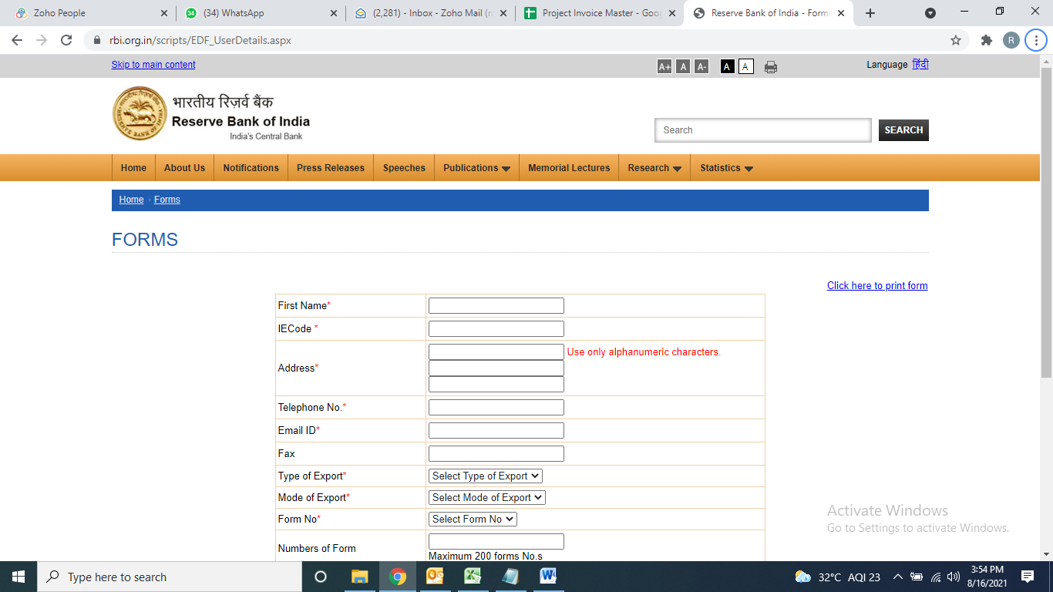

**Required to fill details**

1. **First Name** : Mango IT Solutions
2. **IEC Code** : 1111007357
3. **Address** : 15/03 Old Palasia, Behind Sarda House, Indore
4. **Email Id** : [Accounts@mangoitsolutions.com](mailto:Accounts@mangoitsolutions.com)
5. **Phone No** : 9893024117
6. **Type of Export** : Services
7. **Form No** : Maximum 200 forms

Need to fill all the star marked fields with numbers of forms we need to generate. A pdf file will get generated with the form numbers. Only the form numbers are of use, in that pdf file.

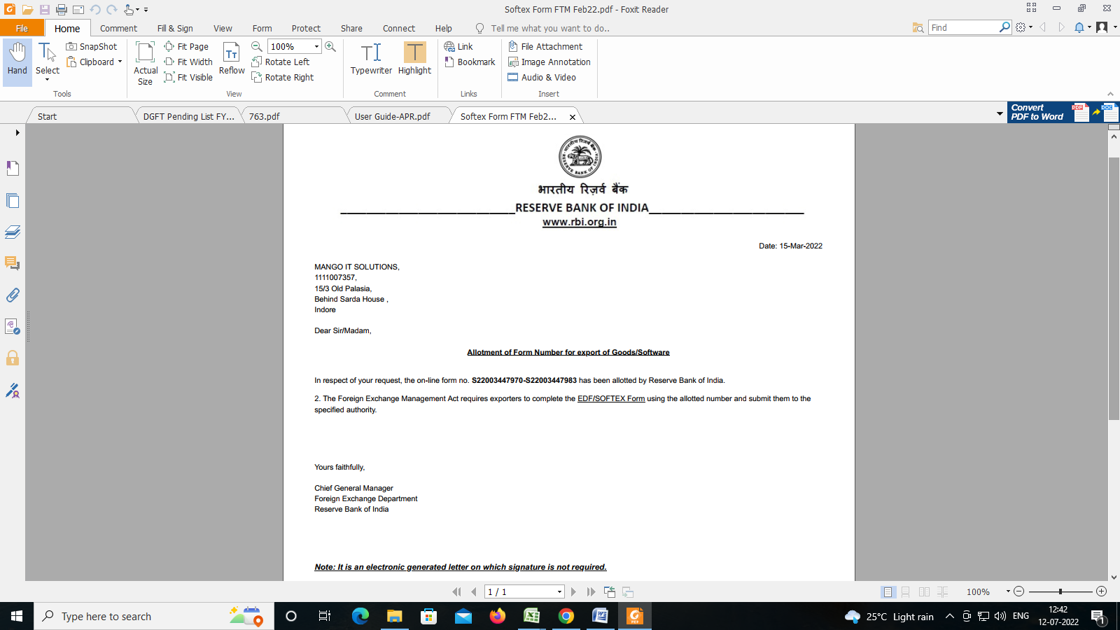

1. **Flow Chart of Softex Process:**

|  |  |  |
| --- | --- | --- |
|  |  |  |
|  | **Softex Forms Generate** |  |
|  |  |  |
|  |  |
|  | **MPR Filling on Month Basis** |  |
|  |  |  |
|  |  |
|  | **Softex Return Filling on Month Basis** |  |
|  |  |  |
|  |  |
|  | **Knock off in Bank** |  |
|  |  |  |
|  |  |
|  | **Check In DGFT Site** |  |
|  |  |  |

1. **How to make client contract with STPI?**

Follow below link: <http://stpionline.stpi.in/unit/jindex.php>

Login using below details:

User ID: stpi2910029

PW: Mit@2018

Select **Export Certification** under the **Export** head from LHS menu bar.

Select **Contract details (2nd option)** from the current window.

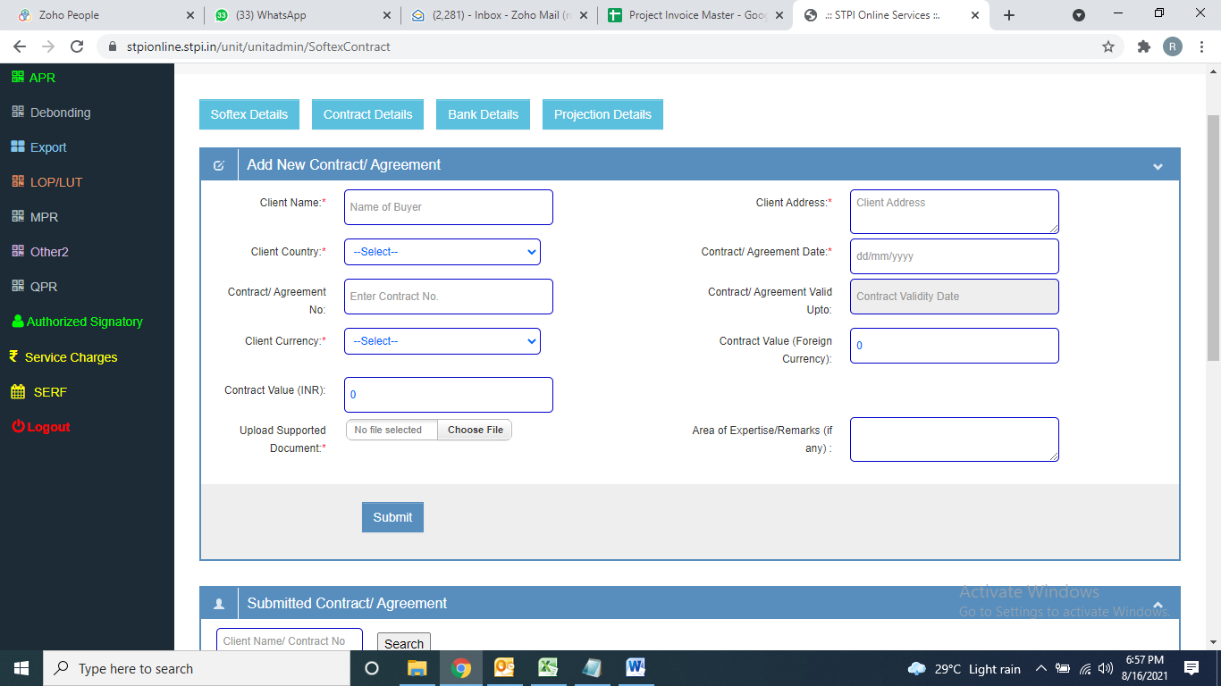

Need to fill all the star marked fields and also upload the signed copy of agreement with that particular client and the **Submit** the same.

A number will get generated after submitting the same, which needs to be saved in Contract Master for future reference.

**Client Contract Master File:**

1. **Serial. No**
2. **Contract No**
3. **Client Name**
4. **Country**
5. **Start Date**
6. **End Date**

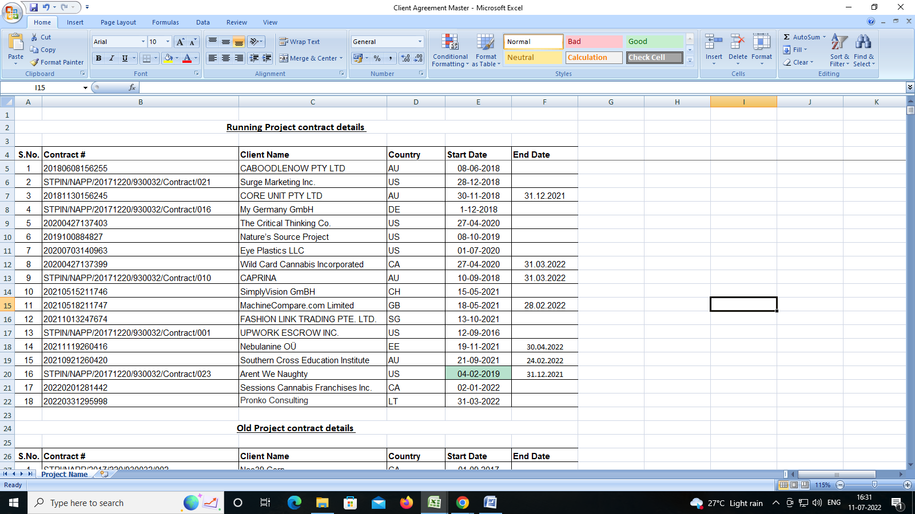

1. **How to file Monthly Progress Report month on month basis:**

Follow below link: <http://stpionline.stpi.in/unit/jindex.php>

Login using below details:

User ID: stpi2910029

PW: Mit@2018

There is a set format from STPI for MPR filing which needs to be filled every month uploaded on the portal

Select **MPR** under the **MPR** head from LHS menu bar.

Select month and year for which MPR to be filed and submit (screenshot is below)

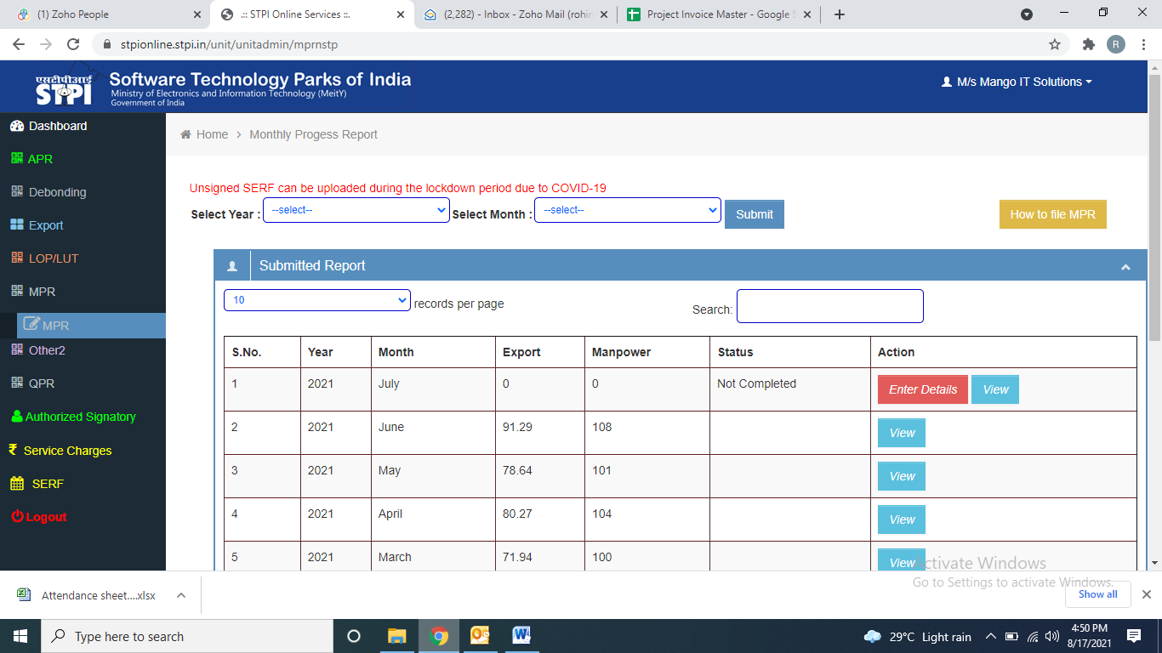

And then press **ENTER Details** as mentioned in above screenshot:

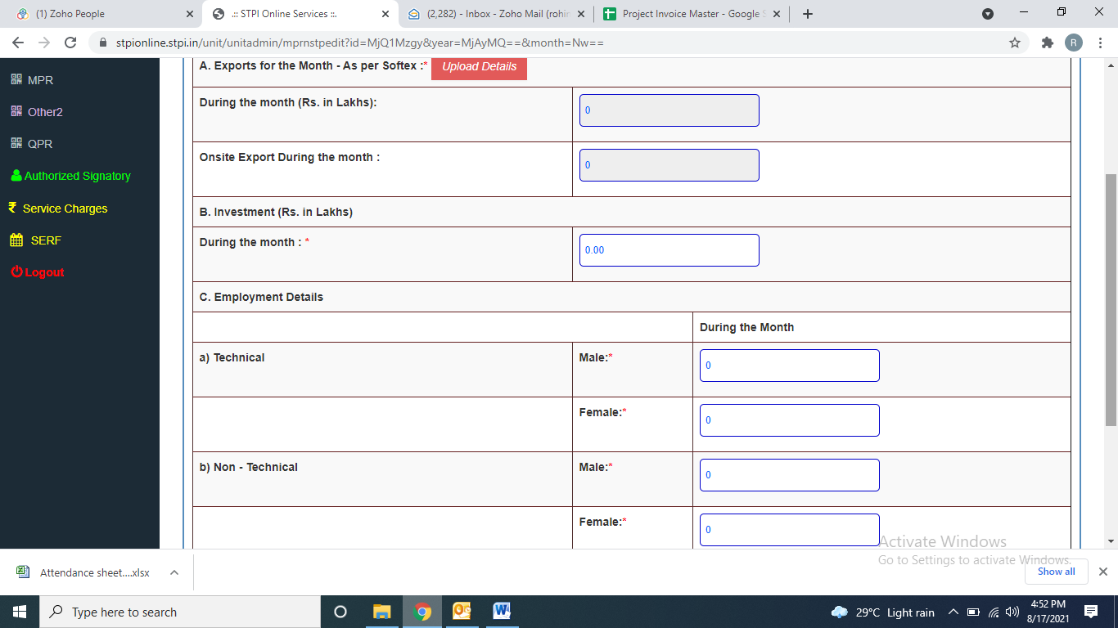

Then press **Upload Details** option

Then on below page upload that sheet (format I mentioned above in which monthly invoice details will be there)

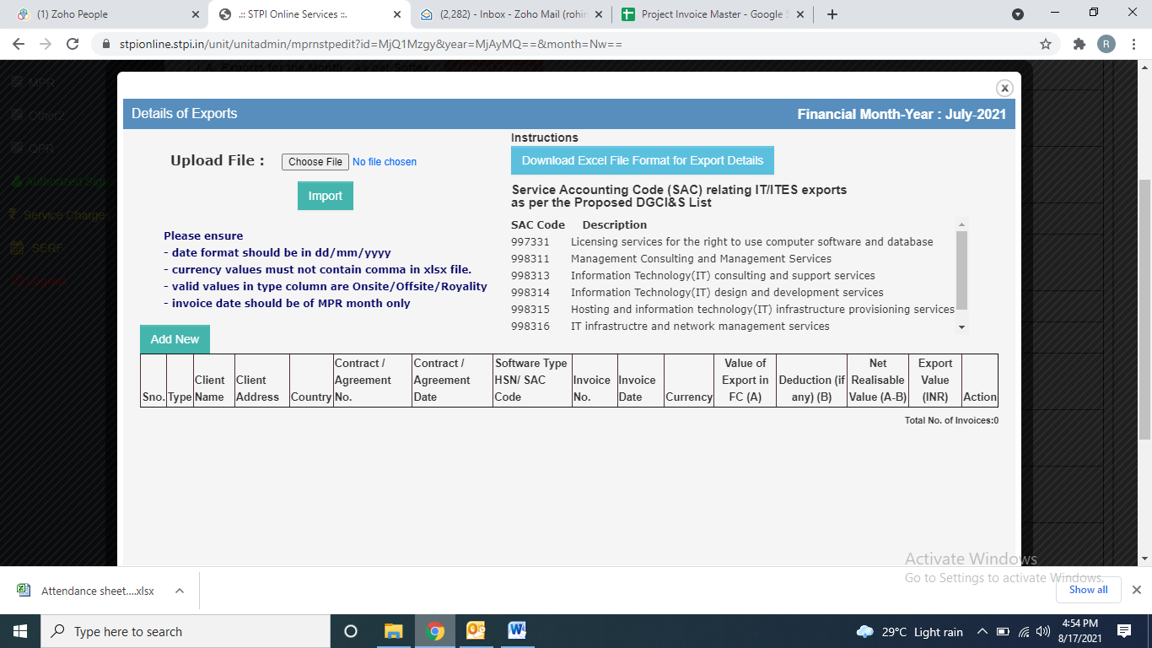

After uploading the sheet **Import** the same, then it will again redirect to previous page:



Now it will automatically fetch the monthly Export(from the uploaded sheet) and then fill rest of the columns:

* 1. **Where can we get the details??**
* Investment details need to be collected from Accountant.
* Employment details to be filled from that month’s attendance sheet.

Then select Vivek Sir’s name from drag down option as authorized signatory and finally **SAVE CHANGES.**

It’s done, in a day or 2 it will get approved by STPI.

1. **How to file Annual progress Report??**

General Instructions:

• Step1 Fill up APR Format and save the form and click on upload.

• Step2 Fill up Export Summary and take the printout. Sign it and store scanned copy of signed document in pdf format on your system.

• Step3 Fill up Feedback Form and take a printout. Sign it and store scanned copy of signed document in pdf format on your system.

• Step4 Download IT Realization format. Fill up details and store pdf of this file in your system

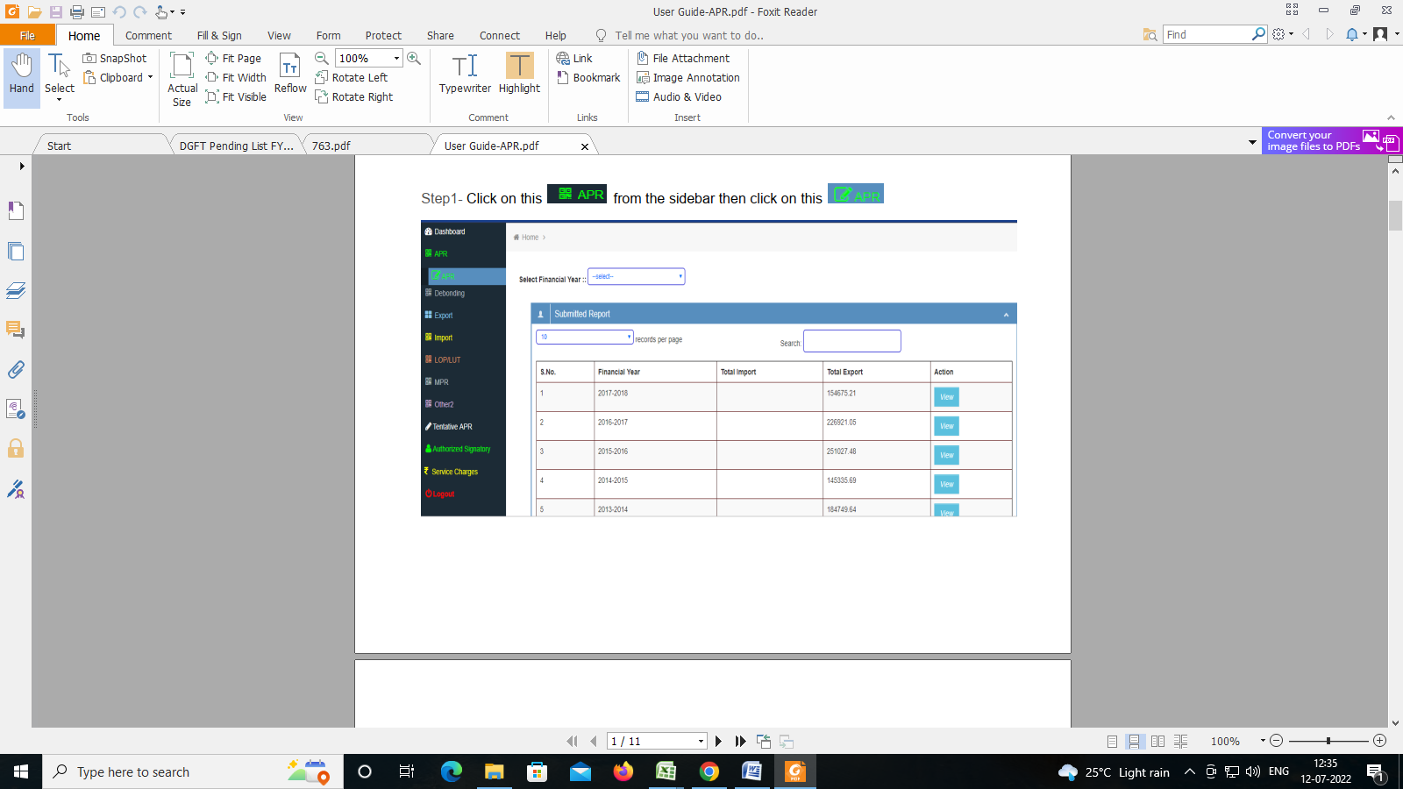

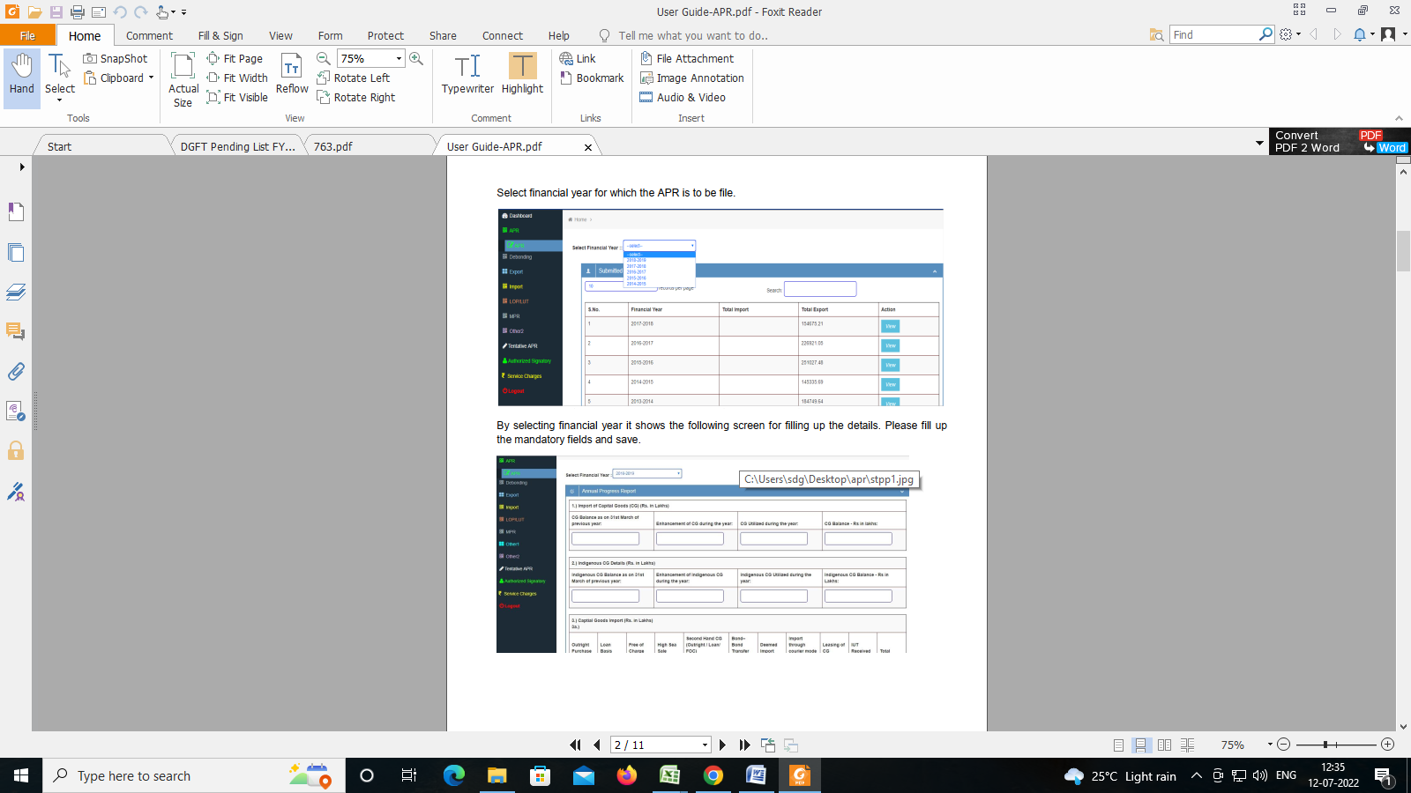

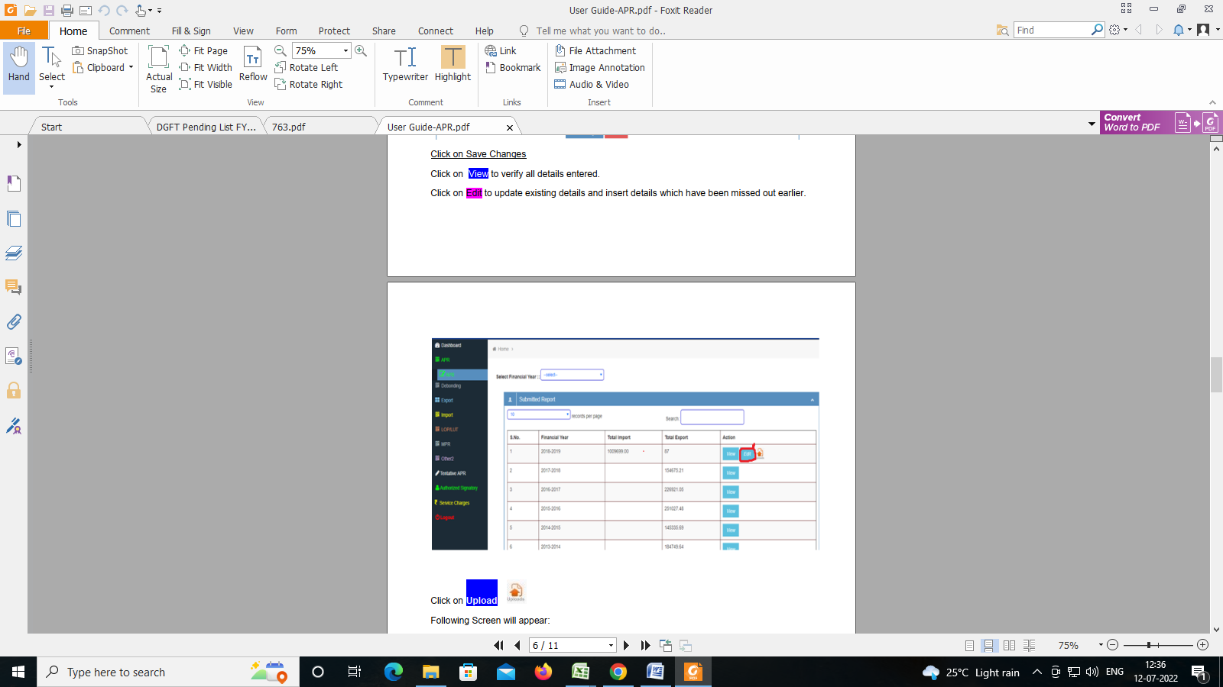

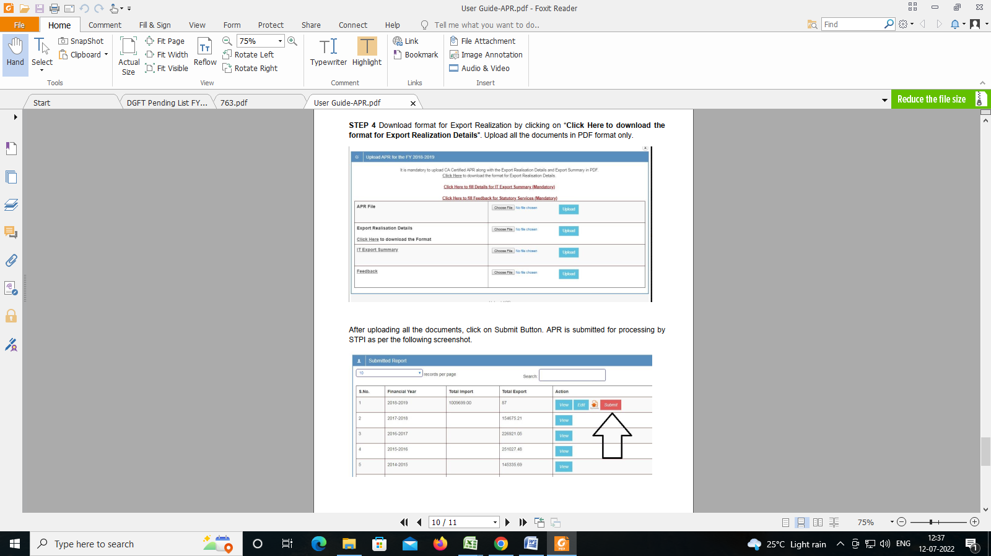

After filling the APR return, we have to give the last year's turnover as per softex and the next year's projection turnover. On that basis the service challan is submitted. Because if the challan is not filled then the returns for the coming month cannot be submitted.

FORM A

**Performa for Declaring the Export Projection Turnover & payment of Service Charges**

1. Name of the NON STP unit : Mango IT Solutions
2. Location Address : 15/3 Old Palasia, Behind Sarda House

: Indore (MP)

1. Registration Certificate No. : STPI/NAPP/20171220/930032/R709
2. Export Turnover Projection : **(Amount in Rs. Lac)**

|  |  |  |
| --- | --- | --- |
| **Table I** | | |
| **FY 2021-22** | **FY 2022-23** | **FY 2023-24** |
| **A** | **B** | **C** |
|  | **800Lacs – 900 Lacs** |  |

5. Amount to be paid towards A/B/C (pls tick) in Table I as per Annual Service Charges mentioned in Table II + GST (as applicable). Payment to be made in the form of DD favoring ***‘Software Technology Parks of India’*** payable at Indore or **NEFT** as per below Details:

**SOFTWARE TECHNOLOGY PARKS OF INDIA**

Account No: 881010110003664

Name of Bank: Bank of India, Vijay Nagar, Indore.

IFSC code: BKID0008810, MICR code: 452013020.

**a).** STPI GSTIN - 23AAATS2468J1ZE

**b).** STPI PAN No.: AAATS2468J

6. Details of DD or NEFT

|  |  |  |  |
| --- | --- | --- | --- |
| **DD/NEFT No** | **DD/NEFT Date** | **DD/NEFT Amount** | **Bank Name** |
|  |  |  |  |

…………………………………

Date : Authorized Signature with Seal

|  |  |  |  |
| --- | --- | --- | --- |
| **Table II** | | | |
| **Annual Service Charges for Non-STP Units : (Amount in Rs.)** | | | |
| **S/N** | **Export Turnover for the year** | **Annual Service Charges** |
| 1 | Upto Rs.12.50 Lakhs | 4,000 |
| 2 | Above Rs.12.50 Lakhs – Rs.25 Lakhs | 8,000 |
| 3 | Above Rs.25 Lakhs – Rs.50 Lakhs | 16,000 |
| 4 | Above Rs. 50 Lakhs – Rs. 3 Crore | 55,000 |
| 5 | **Above Rs. 3 Crore – Rs. 10 Crore** | **110,000** |
| 6 | Above Rs.10 Crore – Rs. 25 Crore | 225,000 |
| 7 | Above Rs.25 Crore – Rs. 50 Crore | 250,000 |
| 8 | Above Rs. 50 Crore – Rs. 100 Crore | 350,000 |
| 9 | Above Rs. 100 Crore – Rs. 500 Crore | 575,000 |
| 10 | Above 500 Crore – Rs. 1000 Crore | 600,000 |
| 11 | Above Rs. 1000 Crore | 650,000 |
| ***\*GST extra as applicable*** | | |

**Note:**

1. After filling up details for Step 1 to Step 3, APR may be viewed to see error messages.

2. Remove all error messages and then take a printout of APR. This is to be signed by Authorized Signatory with Seal and counter signature and stamp of Chartered Accountant. Keep scanned copy of this file in pdf.

3. After completing all these steps, again click on upload button of Step 1 and upload all the four files.

4. Click on Submit Button. Final Submit button will appear if: Service wise export total matches with Export Earnings (slno 3a excluding Deemed• Export). Country wise export total matches with the Export Earnings (slno 3a excluding• Deemed Export). Capital Goods Utilized at slno 1 is equal to Total Capital Goods Imported (3a)• Total Exports in APR and summary of exports are same.• All the four documents are uploaded in pdf format.

1. **How to file Softex month on month basis:**

Follow below link:

<http://stpionline.stpi.in/unit/jindex.php>

Login using below details:

User ID: stpi2910029

PW: Mit@2018

There is a set format from STPI for softex filing which needs to be filled every month uploaded on the portal

Select **Export Certification (Softex)** under the **Export**headfrom LHS menu bar.

Select period for which **Softex** to be filed, select AD code of YES bank( as remittances are credited in YES bank), Select Software Export in Softex Type and finally upload the file as per the format provided by STPI and import is (screenshot is below)

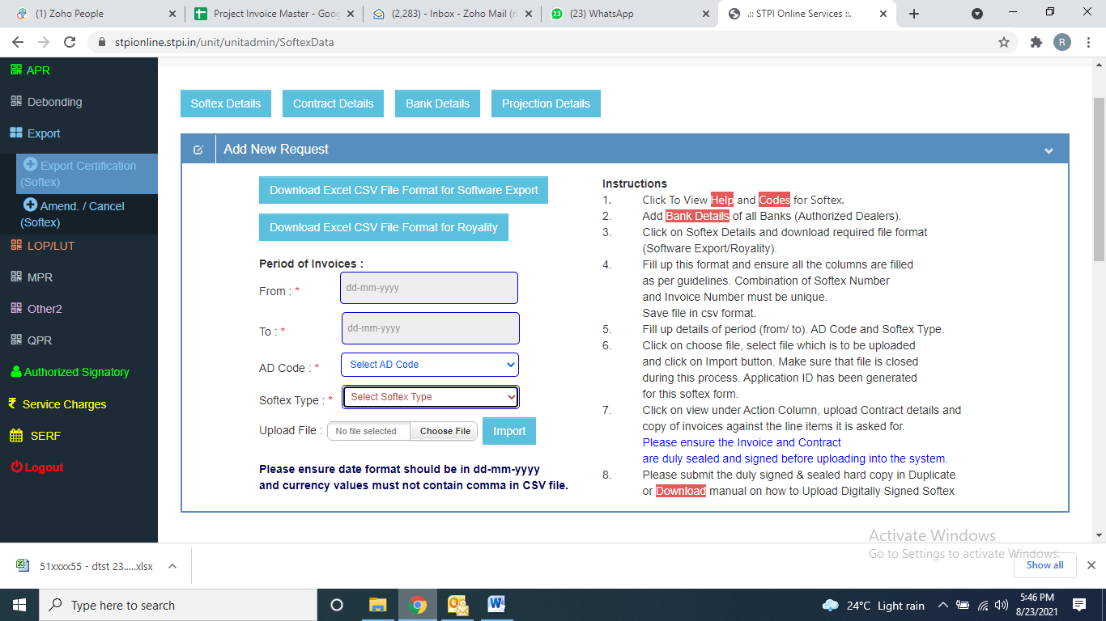

We need to upload excel file to get softex data: As per STPI format

**Softex File.xls**

1. **Contract No**
2. **Contract Date**
3. **Code**
4. **Softex No**
5. **Invoice No**
6. **Invoice Date**
7. **HSN Code**
8. **Currency**
9. **INR Value**

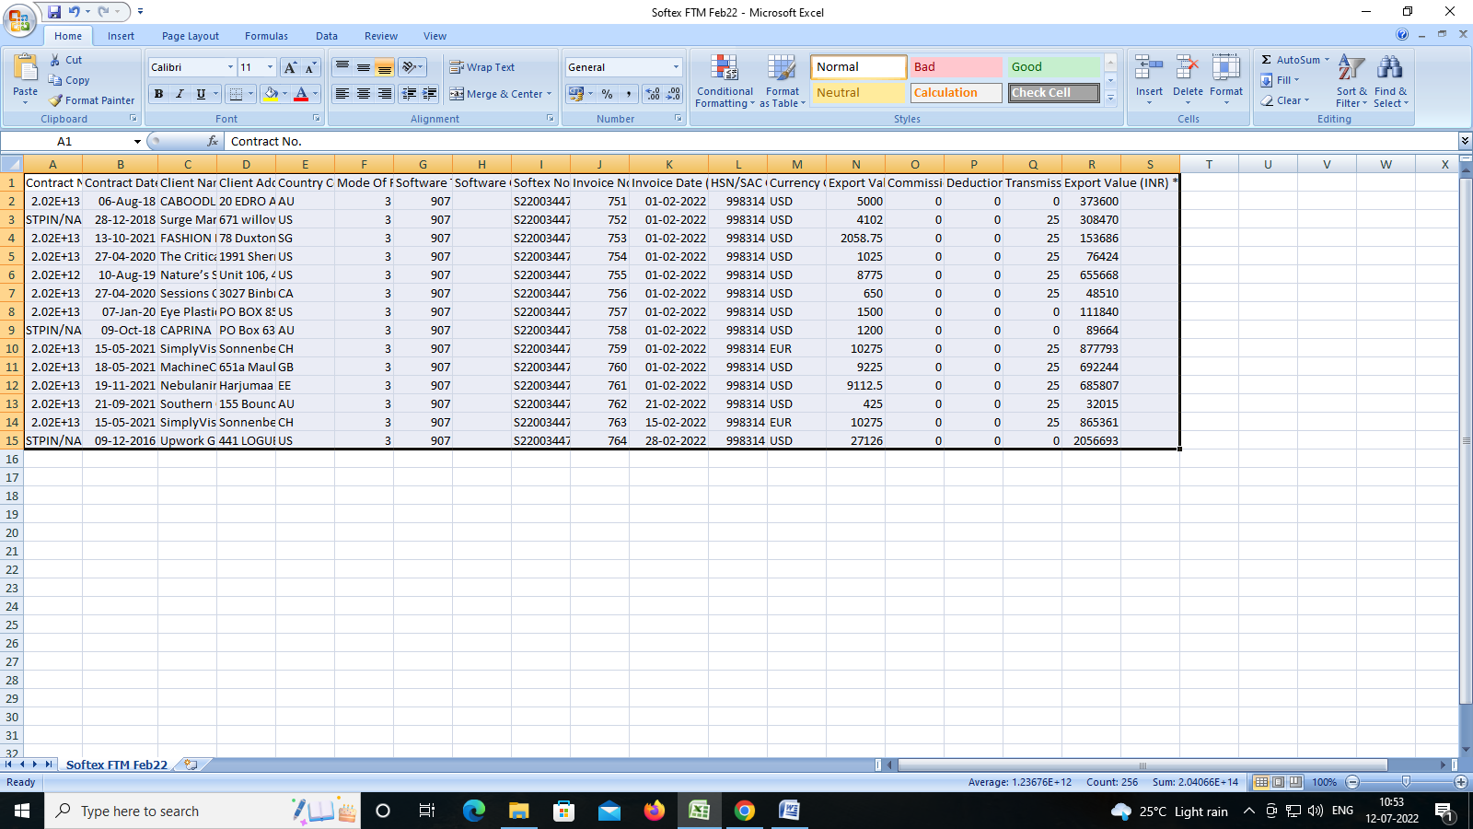

After importing that file below screen will reflect in which that month will start reflecting:

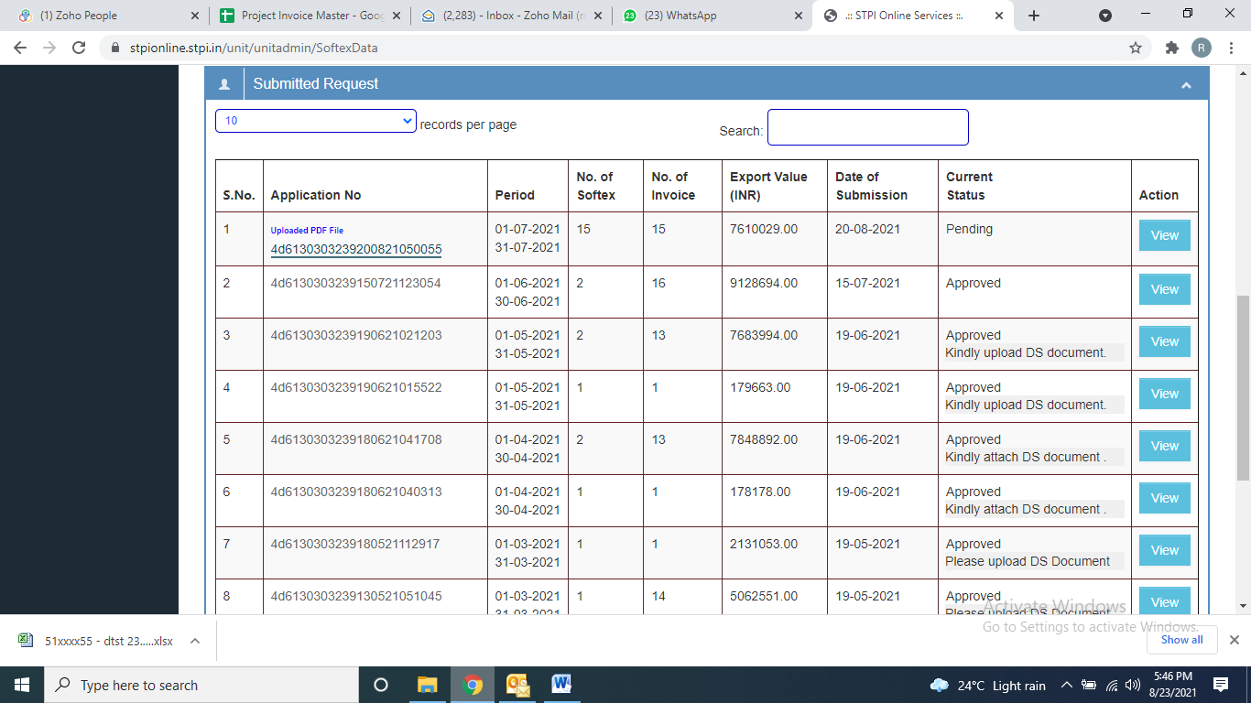

Now it will ask to upload few of the invoices among all the invoices of that particular month.

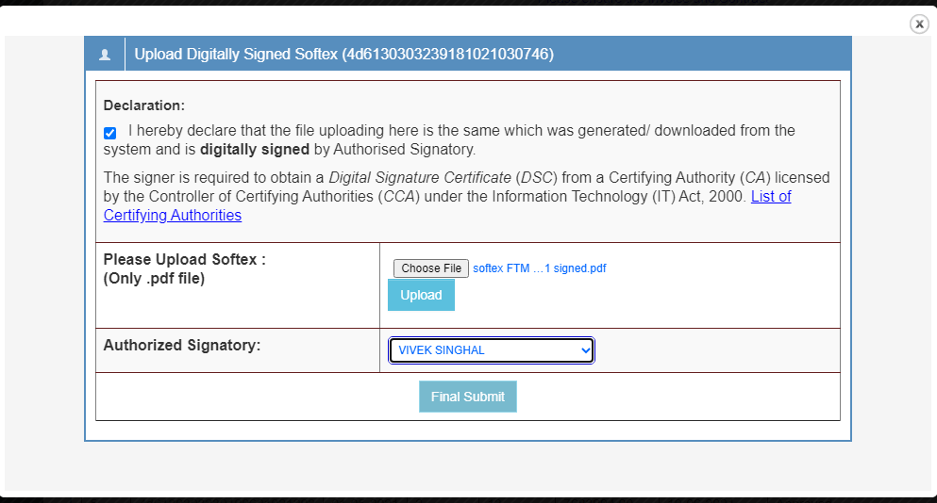

After that we have to send it to company CA for digital signature. After getting the signed copy, it has to be uploaded here. Also we have to take the details in softex master.

After that we update Excel softex master sheet.

**Softex Master.xls**

1. **Client Name**
2. **Country code**
3. **Invoice Master S No.**
4. **Invoice No & Invoice date**
5. **Invoice value**
6. **Softex No**
7. **Bank Advice ref No**
8. **Bank Name**
9. **Softex status**
10. **Bank softex ref No**

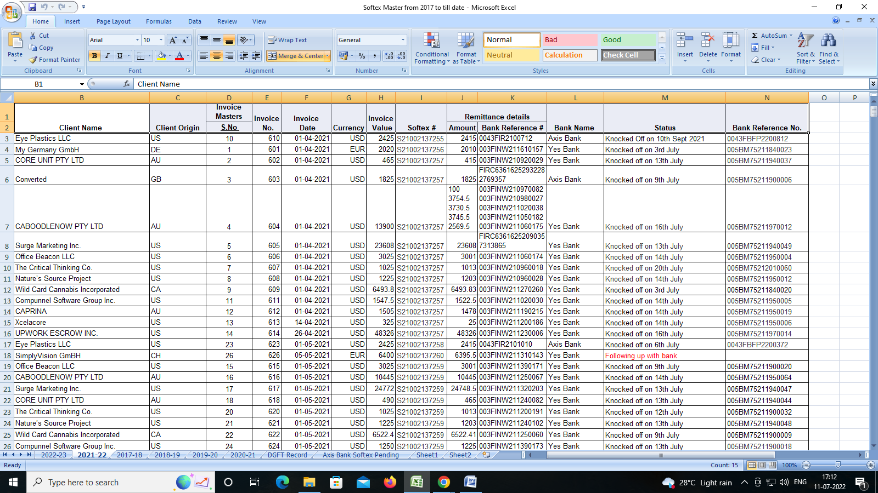

1. **What to do if there is a mistake or correction in the softex???**

Export Certification (Softex ) Amendment/CancellationUnit need to send an email/letter to respective STPI center requesting to provide access to the particular  
Softex number(s) which has to be Cancelled/Amended. Unit must mention all the Softex numbers, to be cancelled/amended, in the above email/letter.  
Please follow the below steps to complete your application pertaining to Amendment/Cancellation once  
STPI grant the access.

Step 1: Open Export Menu from left menu bar. Click on Amend/Cancel (Softex).

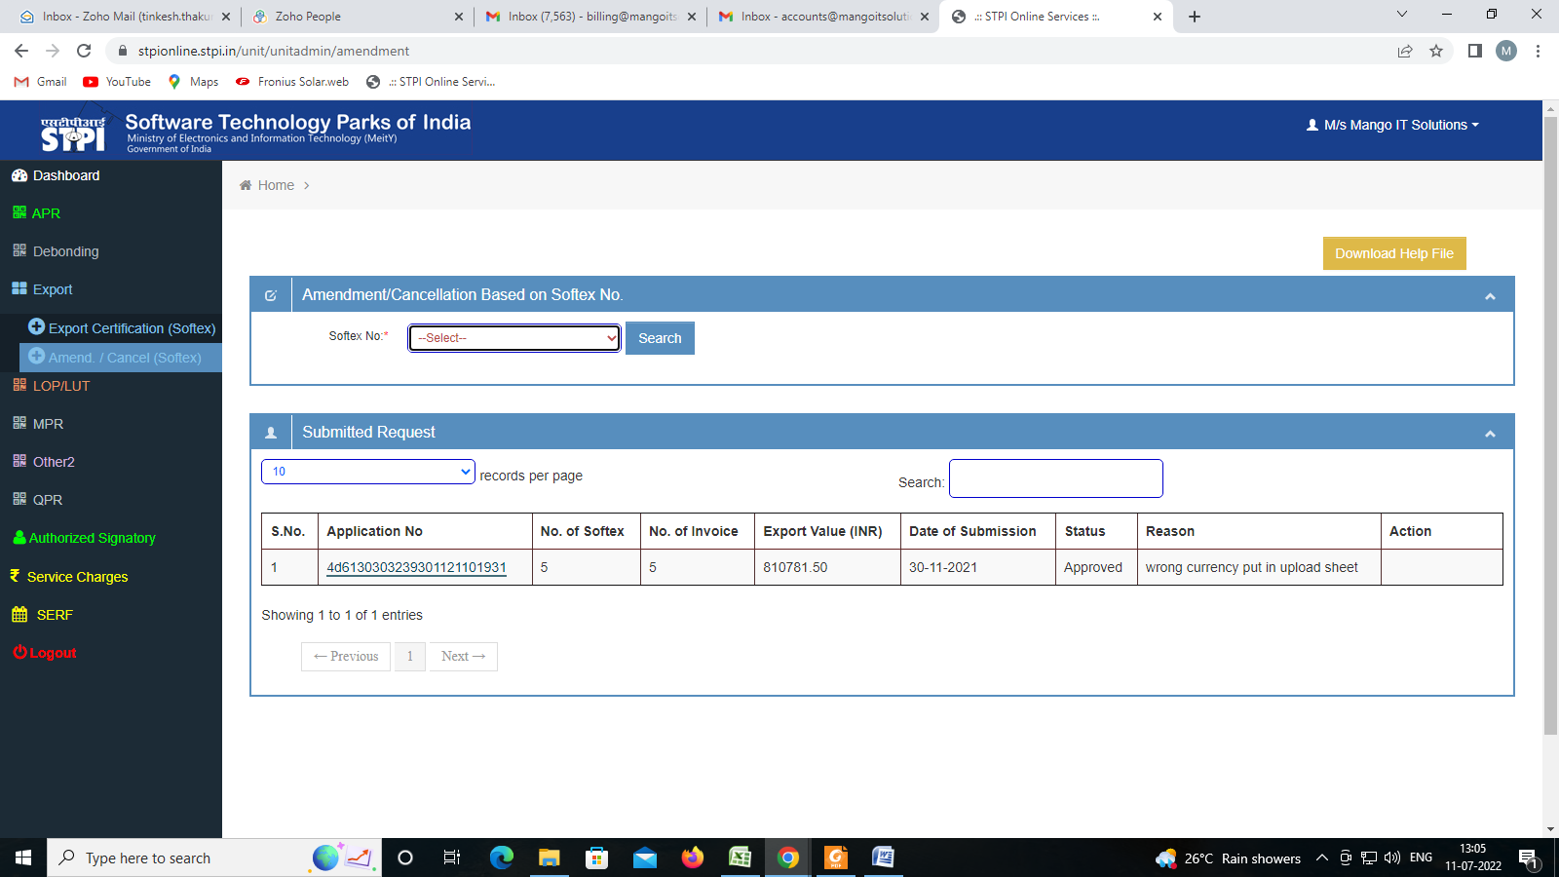

Step 2: Select Softex Number for which invoice data has to amendment/cancellation,Then Click on button.

Step 3: Here is showing list of invoices correspond to softex number.3a: For Amendment click on button.3b: Change data as invoice, and then click on button.3c: If want to cancel request click on button.  
3d: Click on button to upload related document correspond to softex .

Step 4: For cancellation, click on button.4b: If want to cancel request click on button.  
4c: Click on button to upload related document correspond to softex .

Take the printout of the final submitted application. Get it signed digitally (digital signature must bevalid and verifiable) / manual (Sign and sealed) from the authorized person and submit the same tothe respective STPI center (via email).

1. **Why is Softex knock off required??**

The softex form is generated by us on the site of RBI. We need softex number for softex return. When the softex file is filed by us on a return month basis. After that in the bank we have to submit the knock off documents as per the softex number against inward remittance. After that we have to follow up with the bank. When the knock off is completed by the bank. After that we check (DGFT) visit the site and check. Whether our process is completely completed or not.

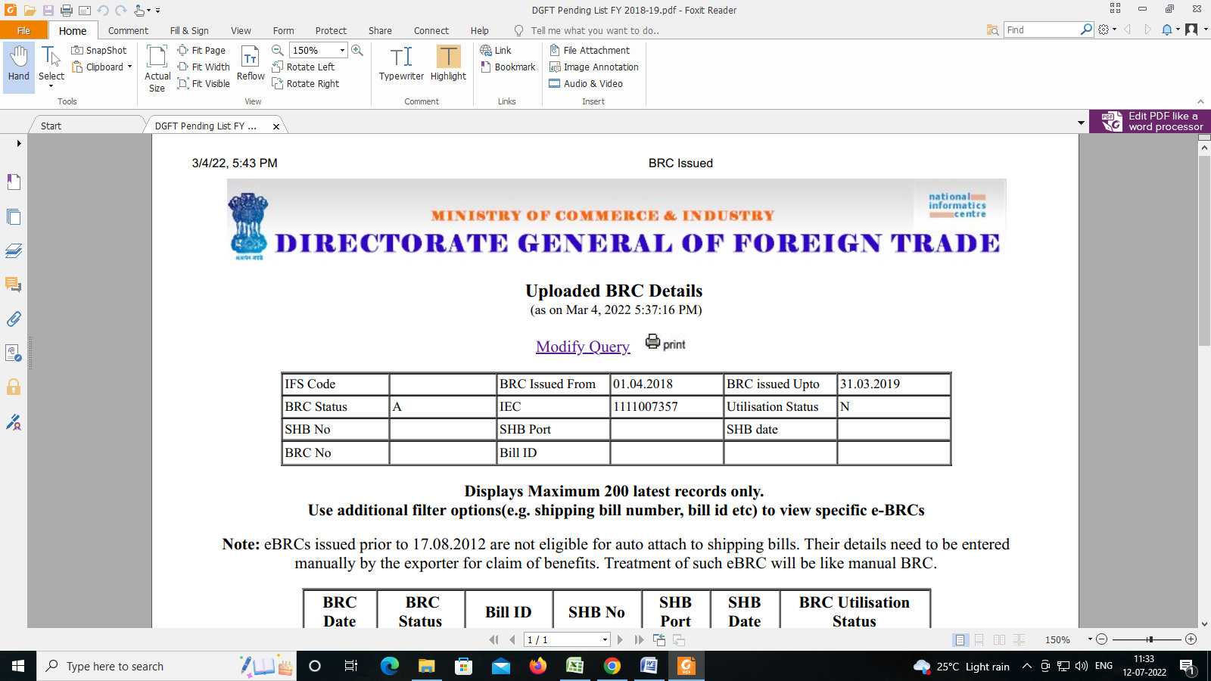

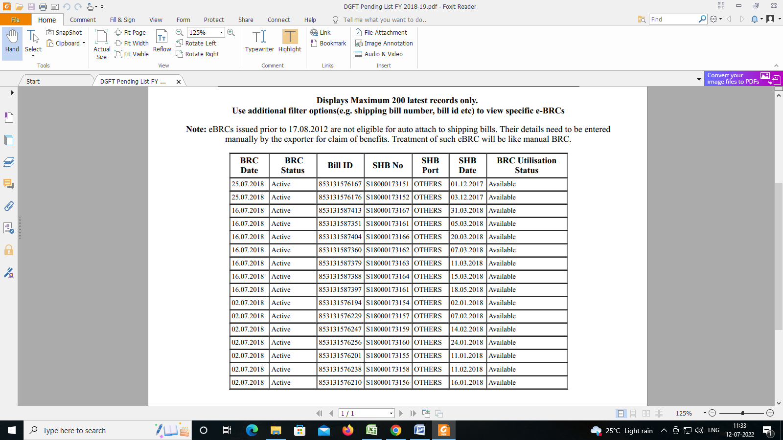

1. **Which documents are needed for knock off process??**
2. **Exporter Name & Details :**

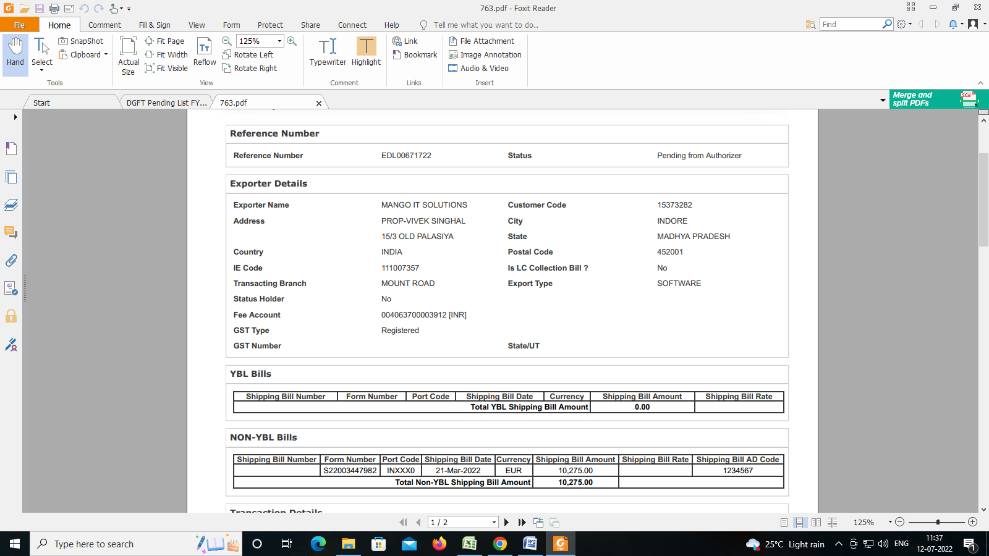

1. **Transaction details :**

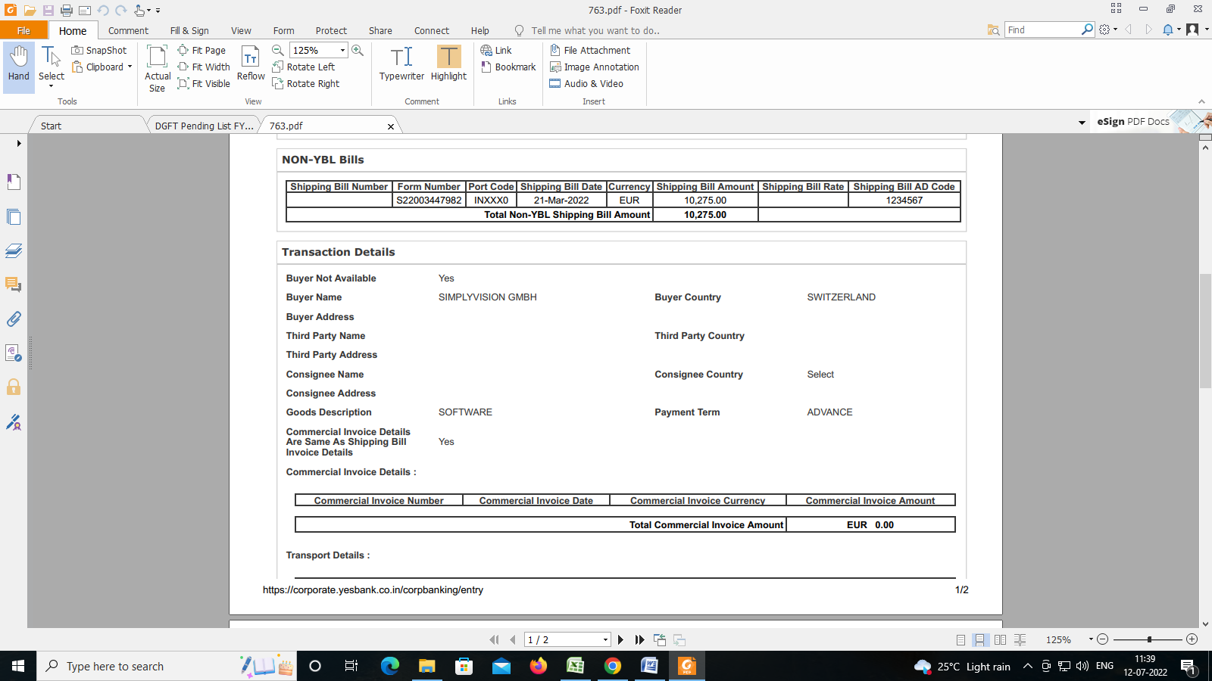

1. **Bank ref. no & Invoice copy & Softex form details :**

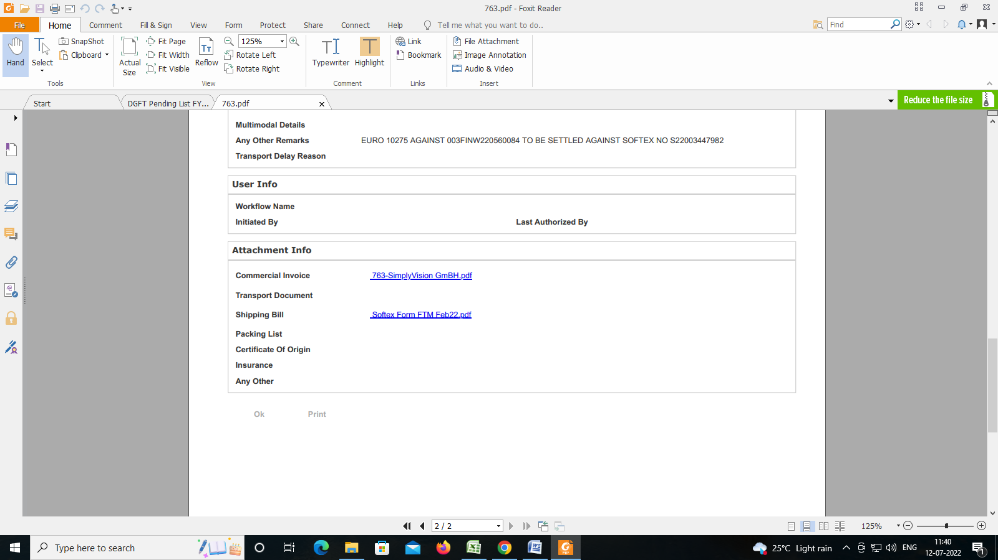

1. **How to file Softex knock offs month on month basis:**

Its complete manual (PPT) is provided by bank itself. After following the instruction of that manual, lastly need to upload few documents.

We only need to attach below 3 documents in the attachment section:

1. Excel sheet with softex and invoice details.(sheet is already prepared, only monthwise sheets to be added every month)
2. Approved softex by STPI for that particular month.
3. All the invoices of that month (USD and EUR separately) need to be merged 1st and then it can be uploaded.

After uploading above document, we just need to submit the application. After successful submission I save the screenshot as below:

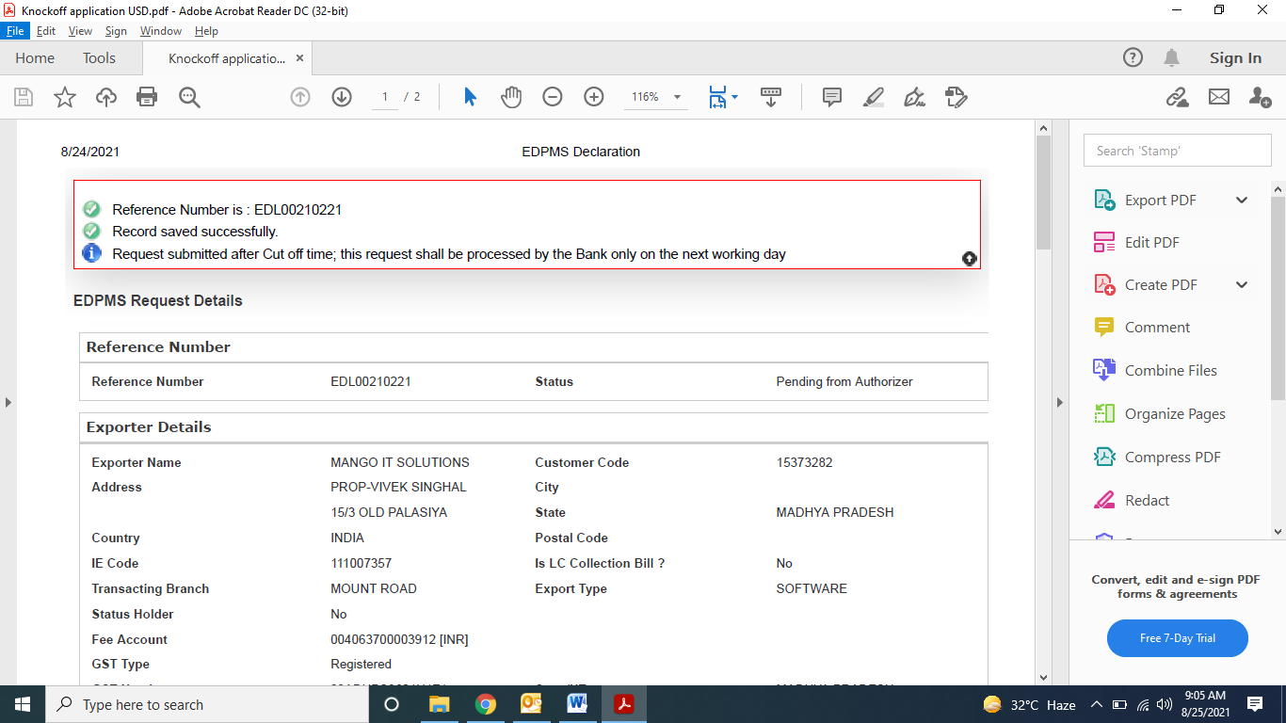

After this Vivek Sir approves the same, and then finally a confirmation email also we receive from bank’s side that our request have been submitted successfully

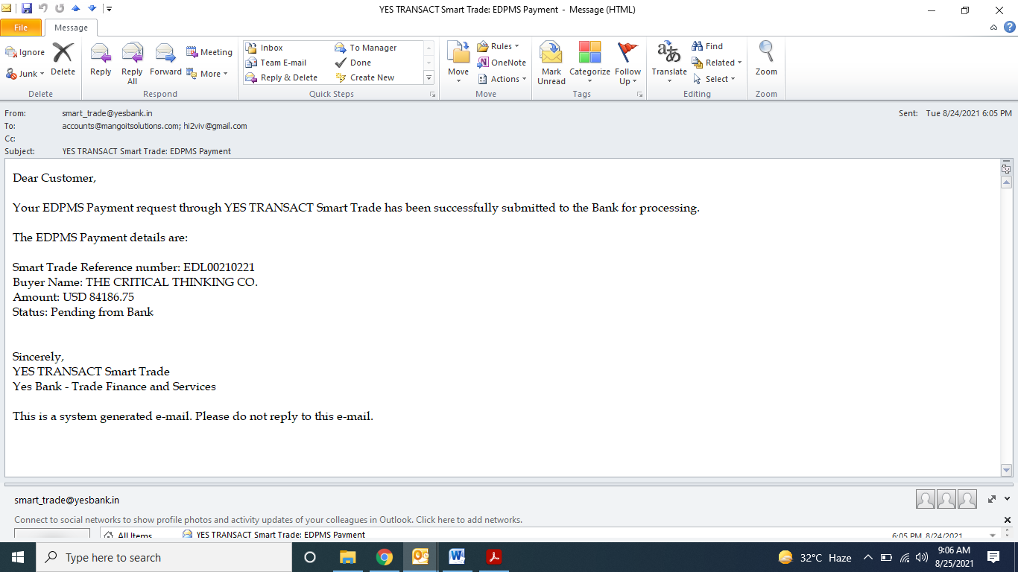

1. **Softex knock off Process:**

STEP-1.

Follow below link: <https://corporate.yesbank.in/iportalweb/iportal/jsps/orbilogin.jsp>

Login ID: ROHINITIWM

PW: Mit@2025

OTP will come to this mail ID: [billing@mangoitsolutions.com](mailto:billing@mangoitsolutions.com)

First of all, in the first page, we will mention company information & company account no.

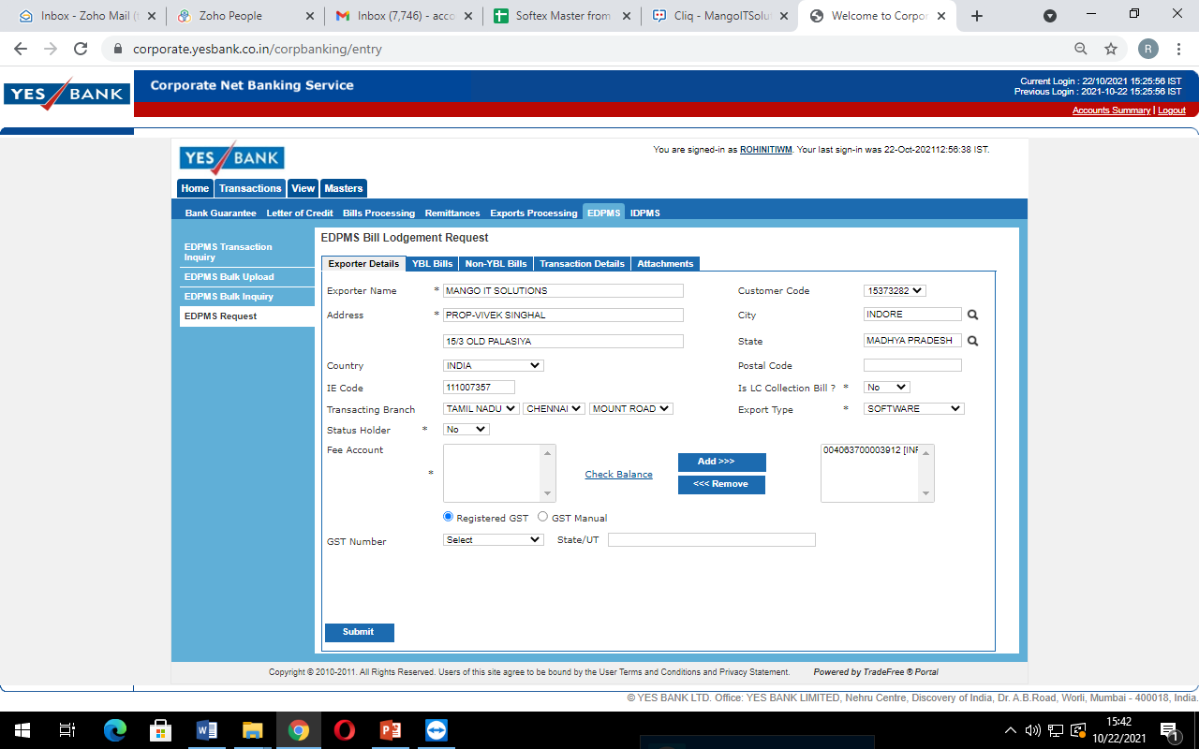

STEP-2.

No information will have to be given in the second page. And we will enter in the next page

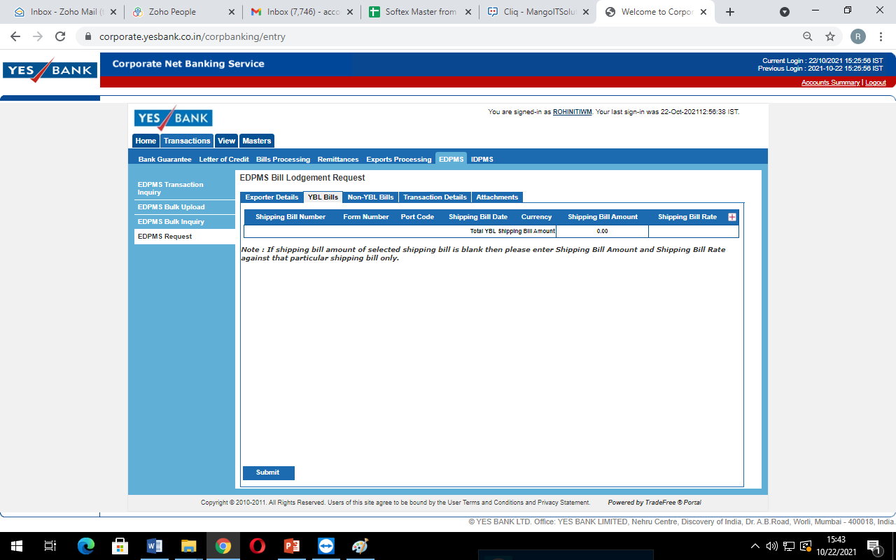

STEP-3

In the third page, we will enter softex no, port code, shipping bill date amount.

After that we will enter in the next page.

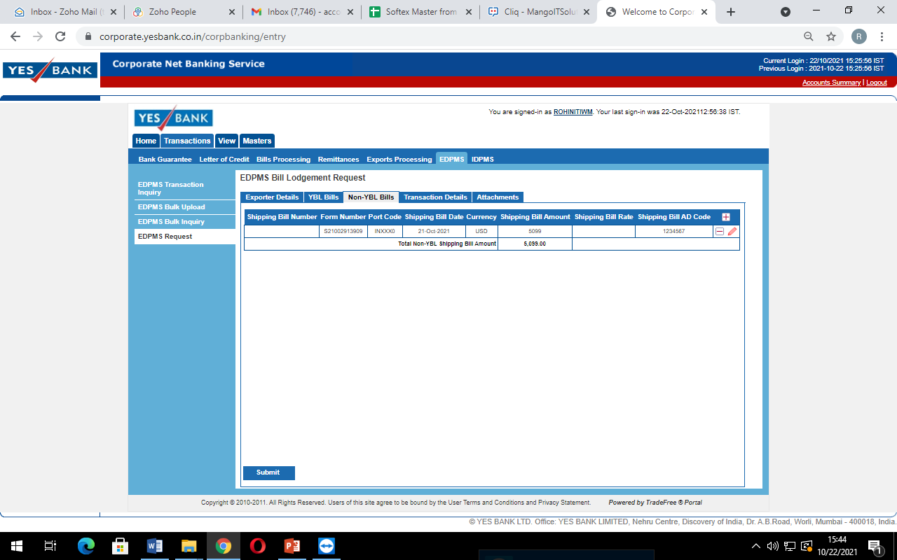

STEP-4

In the fourth page, along with the details of the client, the details of the transport will also have to be filled.

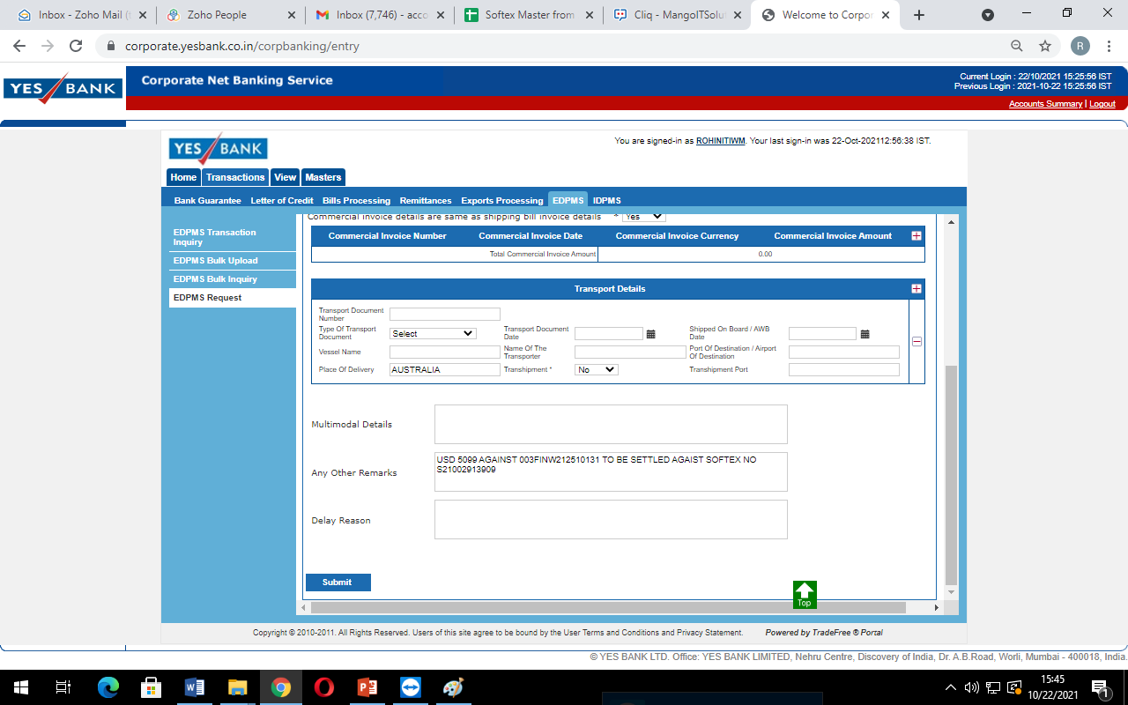

STEP-5

In this we need to attach, Copy of the invoice and RBI Softex no generated form.

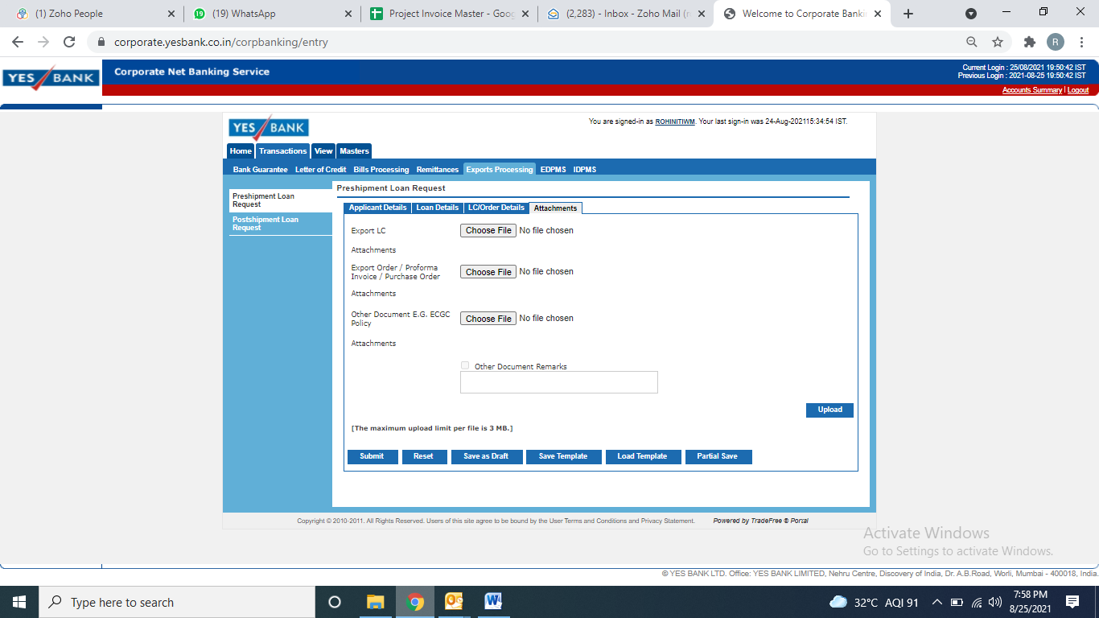

After final submission, need to save the confirmation from bank, later Vivek sir will approve the same.

**11.1 What is PCFC??**

When an advance or a loan is granted, or another form of credit, is provided by a bank to an exporter for the purpose of financing the purchase, processing, manufacturing or packaging of goods before a shipment is called a pre-shipment credit. With the aim to provide the access of credit to exporters at internationally competitive rates, dealers who are authorized have a permit to offer Pre-shipment Credit in Foreign Currency to exporters for domestic and imported inputs of exported goods. This article talks about the process and details concerning Pre-Shipment Credit in Foreign Currency (PCFC).

**11.2 What its purpose of PCFC??**

It helps to meet the working capital requirement before shipment of goods or services for export.

**11.3 Forward contract means??**

The forward exchange contract's purpose is to provide a [hedge](https://www.investopedia.com/terms/h/hedge.asp) for the importer and exporter against the risk of fluctuations in currency exchange rates, which may occur between the time the contract for sale is made and the time when payment is rendered. This is accomplished by the forward contract, specifying the sales price in terms of how much of the importer's currency is required to satisfy the sales price with the exporter's currency. Forward contracts can be made for up to a year in advance.

After booking the forward contract, we enter our records in the forward booking sheet. Which we need while booking PCFC in future.

|  |  |  |  |  |  |  |  |
| --- | --- | --- | --- | --- | --- | --- | --- |
| S.No. | Contract# | Transaction Date | We Bought USD / Nos | Transaction Rate We Sold | INR Value | Delivery From | Delivery To /ON |
| 1 |  | Mar 10,2021 | 47000 | 73.69 | 3463430 |  | May 17,2021 |
| 2 |  | Mar 26,2021 | 45000 | 72.77 | 3274650 |  | Jun 15,2021 |
| 3 | 6730964 | Mar 26,2021 | 45000 | 73.21 | 3294450 | Jul 15,2021 | Aug 13,2021 |
| 4 | 7062639 | July 05,2021 | 50000 | 74.91 | 3745500 | Oct 01,2021 | Oct 29,2021 |
| 5 | 6948501 | June 02,2021 | 50000 | 74.25 | 3712500 | Nov 01,2021 | Nov 30,2021 |
| 6 | 7053620 | July 01,2021 | 50000 | 75.6 | 3780000 | Dec 01,2021 | Dec 31,2021 |
| 7 |  | Aug 11,2021 | 50000 | 75.35 | 3767500 | Jan 01,2022 | Jan 31,2022 |
|  |  |  | 337000 |  | 25038030 |  |  |
|  |  |  |  |  |  |  |  |

1. **Invoicing Process @ MIT:**

|  |  |  |
| --- | --- | --- |
|  |  |  |
| **Monthly Invoicing USD /Euro** |  |  |
| |  | | --- | |  | |  |  |
|  |  |  |
|  | |  | | --- | |  | | **1. Direct Conversion** |
|  |  |  |
| **Bank Inward Remittance** |  | **2. In EEFC Account** |
| |  | | --- | |  | |  |  |
|  |  | **3. Fill in PCFC** |
|  |  |  |
| |  | | --- | |  | |  | **1. Softex Form Generate** |
|  |  |  |
|  |  | **2. Softex return** |
| **STPI Process** |  |  |
|  |  | **3. Softex Approval** |
|  |  |  |
|  |  | **4. Softex Knockoff** |
|  |  |  |
|  |  |  |

* **Address of the file and folder useful for creating the invoice –**

**Computer Drive - F\Mango IT Updated Doc 23.02.2022\Invoices\Invoices\Invoices-Rohini Tiwari\Invoices**

* **Required to fill in details**
  1. **Company name & Address with country**
  2. **Client name & Email ID**
  3. **Date & Invoice No**
  4. **Time period of Invoice**
  5. **Payment term**
  6. **Project Code**
  7. **Description & Rate**
  8. **Banking details ( USD & EURO )**
* **Points to Note: -**
* **We have to generate the invoice by the 25th of every month.**
* **For hourly details, we have to get the details from our TPL by email.**
* **After we have received the details with hours, then we start the process of generating the invoice.**
* **After creating the invoice, we check it and send it to our CTO Sir for approval.**
* **Then we send it to our client for payment.**
* **To create an invoice, according to the format of the invoice, the necessary details given above will be filled in it.**

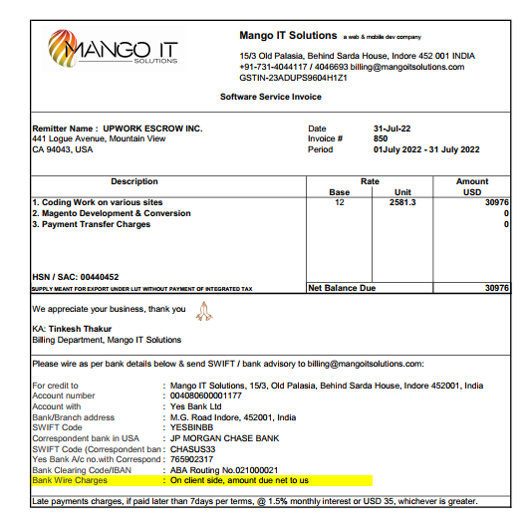

After that we update Excel Invoice master sheet.

**1.Client Name, 2. Client Address and Country 3. Client Contract No# 4. Client Contract Date, 5. Client Email, 6. Owner Name, 7. Invoice No. 8. Invoice Dete 9.Invoice Duration 10. Currency 11.Invoice Amt. 12.Transfer charges. 13. Net Receibal.**

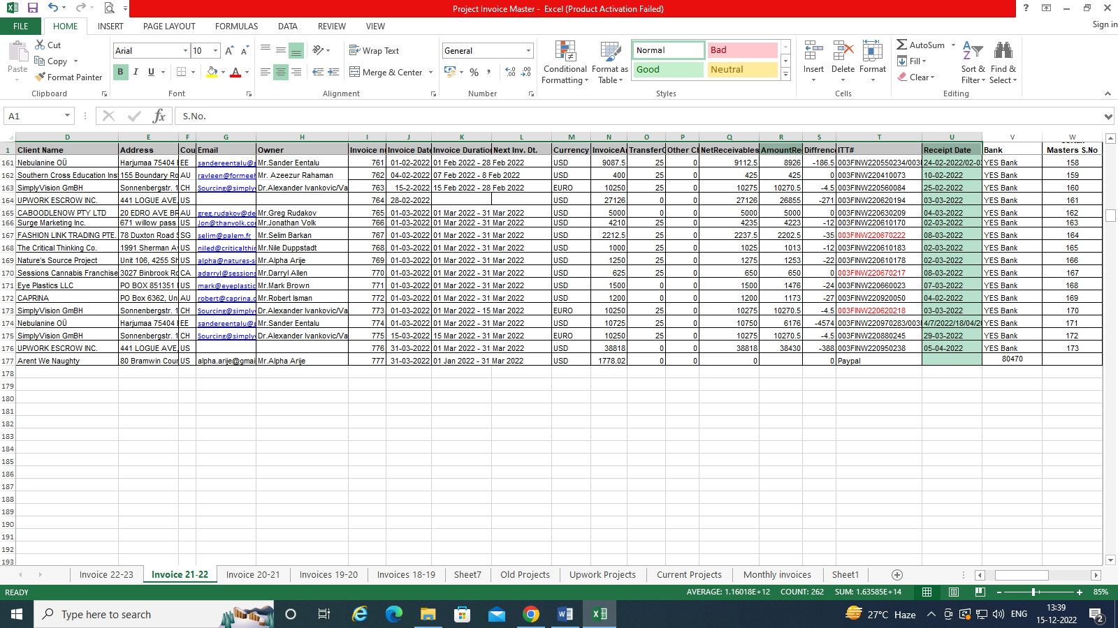

1. **What do we have to do when inward remittance comes??**

When the inward comes to the bank, the bank sends us the details of the inward remittance.

 Dear Sir/Ma'am,

Greetings from YES BANK LTD....

We have received the below remittance on behalf of your company.

Request you to kindly provide us with the disposal instructions along with Purpose of Remittance. And give your confirmation regarding your account number in which the said amount to be credited.

**Inward detail-**

BENEFICIARY NAME

CURRENCY

AMOUNT

BENEFICIARY ACCOUNT NO

SENDER REF NO

Please fill the format as provided in the appended e-mail body itself.

Hello Team,

I/We authorize you to credit all the foreign inward remittances received in my/our favour, as per the below mentioned details:

|  |  |
| --- | --- |
| **Conversion details (Tick  whichever is applicable):** | * Convert 100% into INR and credit my/our a/c no ______________________________ * Credit 100% amount to my/our EEFC a/c no. __________________________________ * Convert .............................(CCY & amount) into INR and credit my/our a/c no._______________________________ and credit the balance ...........................(CCY & amount) to  my/our EEFC a/c no._____________________      * I/We confirm that we have not taken any packing credit against the said inward remittances |
| * Liquidation of EPC / PCFC on FIFO basis   **PCFC no 594PCFC220340005 ( for period 03 Feb 22-**  **08 Aug 22)** |
| **INR a/c no. for deduction of Bank’s charges along with applicable statutory levies** | **004063700003912** |
| **Name of the ultimate country to whom services have been rendered.** | **Country Name** |
| **Note: In case the Payment belongs to Export of Services and falls under purpose group nos. (02, 03, 05, 06, 07, 08, 09, 10, 11, 15, 16 or 17) then mandatory to mention the name of the ultimate country receiving services.** | |

|  |  |  |
| --- | --- | --- |
| **Purpose (Tick a as applicable)** | **Details** | **Purpose Code** |
| ü**Software/ Service exports *(Registered under STPI. Softex applicable*.)** | We confirm that the above remittance is on account of ‘software/service’ made by us and relative export documents has been / will be submitted to you within One Year i.e. March’2023 (approx. date or month) and that the transactions does not pertains to fully prohibited under OFAC sanction countries | **P0807** |

**Declarations by the customer**

In respect of advance against Exports of Goods and Services *(strike whichever is not required)*, I/we undertake that I/we am/are under an obligation to ensure that the shipment of goods and services is made within one year from the date of receipt of advance payment. In the event my/our inability to make the shipment partly or fully within one year from the date of receipt of advance payment, no remittance towards refund of unutilized portion of advance payment or towards payment of interest, shall be made after the expiry of the said period of one year, without the prior approval of the Reserve Bank. The documents covering the shipment will be submitted to YES BANK Ltd. within 21 days from the date of shipment.

I/we also declare that the transaction does not have linkage with any Specially Designated Nationals and Blocked Persons (SDN)/countries listed under OFAC in any manner. If the transaction involves linkage with any Specially Designated Nationals and Blocked Persons (SDN)/countries listed under OFAC in any manner, I/we undertake not to hold YES Bank Limited responsible for any of its action or inaction in respect of the OFAC-linked transactions.

Further, I/we declare that the transaction does not involve payment from/to a Third Party. If the transaction involves payment from/to a Third party, I/we undertake to comply with the extant guidelines from RBI / the Bank in this regard. In respect of Merchanting Trade, I/we declare to abide by the extant guidelines of RBI.

Further, I/we undertake to submit copy of Invoice/Agreement or any other document if Bank or any other Regulatory authority require the same in future.

**The declaration-cum-undertaking under Sec 10(5), Chapter III of FEMA, 1999**

I/We hereby declare that the transaction details of which are mentioned above does not involve and is not designed for the purpose of any contravention or evasion of the provisions of the aforesaid Act or of any rule, regulation, notification, direction or order made there under. I/We also hereby agree and undertake to give such information / documents as will reasonably satisfy you about this transaction in terms of the above declaration. I/We also undertake that if I/we refuse to comply with any such requirement or make only unsatisfactory compliance therewith, the Bank shall refuse in writing to undertake the transaction and shall if it has reason to believe that any contravention / evasion is contemplated by me / us report the matter to RBI. I/We further declare that the undersigned has the authority to give this application, declaration and undertaking on behalf of the firm/company.

Warm Regards,

1. **How to fill PCFC & EPC with inward remittance??**

When the inward comes to the bank. After that the bank asks us for confirmation. Whether we want to transfer to inward account or adjust in loan. When we have to make adjustments in the bank loan, we give the confirmation in the format of the bank. According to the advice of the bank, we take how much fund is adjusted in our sheet.

1. **Cross currency Transactions.**

Cross Currency Transactions let you convert a foreign currency into a different currency, For example, you might convert US dollars to Euros, or Australian dollars to British pounds.



For example, if PCFC was initially taken for a period of 3 months and in the beginning of the second month the exporter 12 submits an export bill for adjustment of PCFC, then the difference between 3 months funding cost (e.g. LIBOR + 2% + 0.75%) charged to the customer and the interest at which foreign currency funds delivered early by the exporter can be deployed for the balance period i.e. 2 months (e.g.2 months LIBOR + 2%) should be charged to the customer (2.75% - 2% = 0.75%) subject to a minimum of 2%. The minimum penalty of 2% is to be levied even if there is no extra cost to the Bank.

After that we received from the bank Payment Inward remittance credit advice update Excel Invoice master sheet.

**1.Amount Received 2.Bank Remittance FIN No. 3.Remittance date.**



1. **How to book PCFC ONLINE?**

Follow below link: <https://corporate.yesbank.in/iportalweb/iportal/jsps/orbilogin.jsp>

Login ID: ROHINITIWM

PW: Mit@2025

OTP will come to this mail ID: [billing@mangoitsolutions.com](mailto:billing@mangoitsolutions.com)

**Things to keep in mind while of booking PCFC**

USD / EURO - Depends on incoming funds

Amount – INR value of PCFC

Interest rate - Have to confirm before bank

Days – 180-2 = 178 days (To save interest)

Select **Trade** from **LHS** menu bar

First we will enter the details of applicant details, loan request date, disbursement date, period of loan, all these.

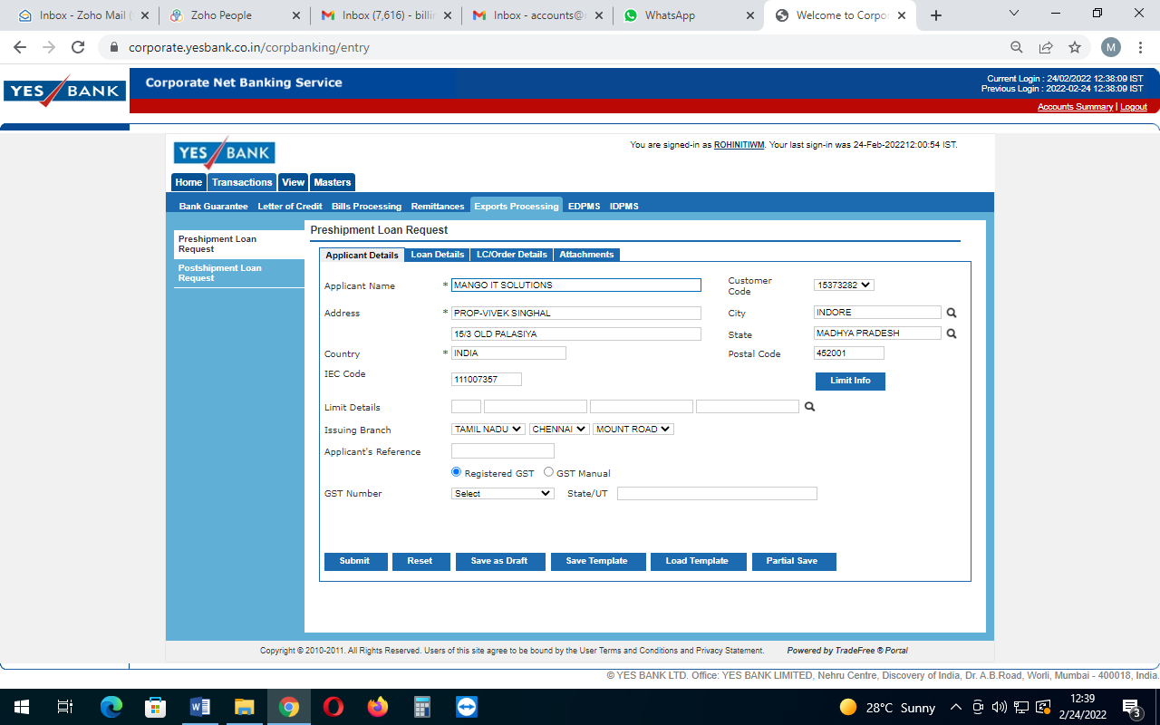

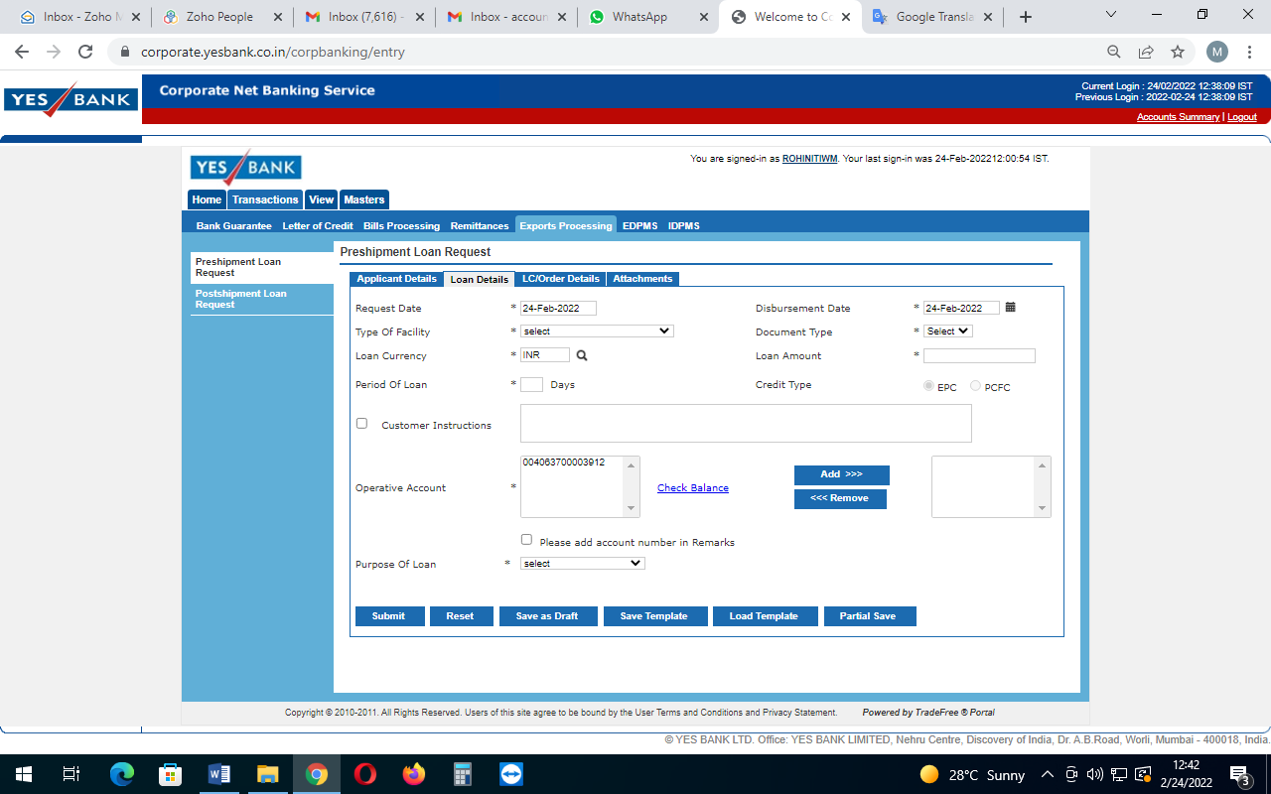

Then select **Transaction,** select **Export Processing,** then select **Preshipment Loan Request**

Rest whole process is there in the manual by bank.

In this we need to attach, Signed copy of invoice(for PCFC of $50K, we prepare invoice for $60K)



After final submission, need to save the confirmation from bank, later Vivek sir will approve the same.

1. **How to book EPC ONLINE?**

Follow below link: <https://corporate.yesbank.in/iportalweb/iportal/jsps/orbilogin.jsp>

Login ID: ROHINITIWM

PW: Mit@2025

OTP will come to this mail ID: [billing@mangoitsolutions.com](mailto:billing@mangoitsolutions.com)

**Things to keep in mind while of booking EPC**

Amount – INR value of EPC

Interest rate - Have to confirm before bank

Days – 180-2 = 178 days (To save interest)

Select **Trade** from the **LHS** menu bar

First we will enter the details of the applicant details, loan request date, disbursement date, period of loan, all these.





Then select **Transaction,** select **Export Processing,** then select **Preshipment Loan Request**

Rest whole process is there in the manual by bank.

In this we need to attach, Signed copy of invoice (for EPC of $50K, we prepare invoice for $60K) and UDIN Registration.



After final submission, need to save the confirmation from bank, later Vivek sir will approve the same.

1. **MPSEDC Interest Subsidy Process:**
2. **Logging in to your account:**

Follow below link: <http://mpsedc.mp.gov.in/Login.aspx>

Login ID: MPSEDCITPC20171277

PW: Mit@2025

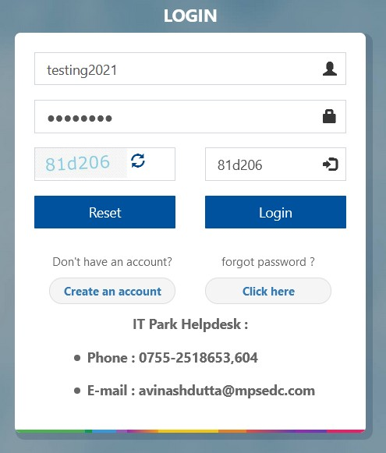Fill out the User-ID and Password enter the captcha as shown and press login

**Note:** In case you have forgotten the password please use the forgot password feature and follow the steps below:

* 1. Enter User Name
  2. Enter Captcha as shown
  3. Press Submit
  4. You will receive OTP on your registered Mail-ID and Mobile No. verify the same and press submit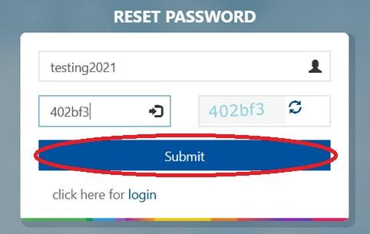
  5. Your password will be reset and fresh password will be sent to your registered Mail-ID
  6. Login with the fresh password and change your password

# Interest Subsidy:

If you have claimed Interest Subsidy earlier, click on Yes and fill out the complete details and save. If you have not claimed the same click on No and move ahead with your current application.

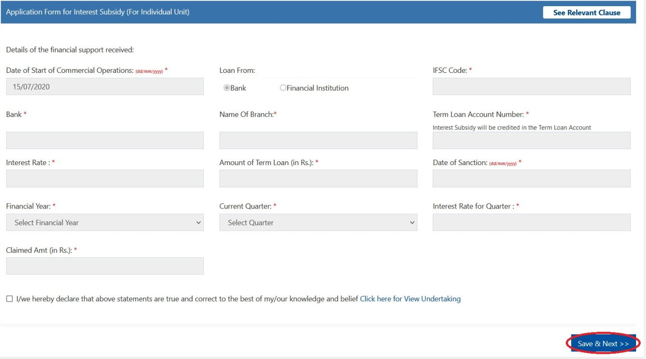

Details to be filled in the application:

1. **Date of Start of Commercial Operations:** Auto-populated
2. **Loan From:** Selection of the Type of Organization you have taken from
   * 1. Bank
     2. Financial Institution
3. **IFSC Code:** If Bank IFSC Code of the bank
4. **Bank:** Name of the Bank/Financial Institution
5. **Name of Branch:** Branch name of the Bank/Financial Institution
6. **Term Loan Account Number:** Term Loan Account number as provided by the Bank/Financial Institution
7. **Interest Rate:** Interest Rate at the time of sanction of term loan
8. **Amount of Term Loan:** Amount of term loan acquired
9. **Date of Sanction:** Date of sanction of the term loan
10. **Financial Year:** Financial Year of the period you are applying for
11. **Current Quarter:** Quarter for which Interest Subsidy is being claimed
12. **Interest Rate for Quarter:** Interest Rate for the quarter
13. **Claimed Amount:** Interest Subsidy amount that is being claimed
14. **Undertaking:** Clicking on I/we hereby declare that the above statements are true and correct to the best of my knowledge and belief
15. Move ahead with clicking on Save & Next for uploading of the documents.

# Upload Documents:

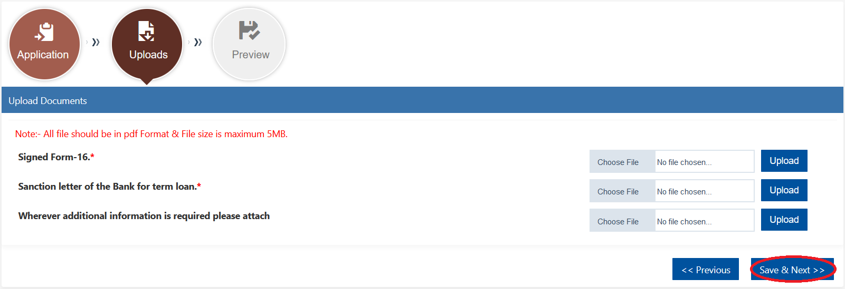

* + 1. Signed Form-16
    2. Sanction letter of the Bank for Term Loan

After uploading documents click on Save & Next which will bring you to the preview page. Once previewed and if corrections are needed click on “Previous” if no corrections are required move ahead by clicking “Final Submit”. If corrections are required follow the same process as given above and submit your application after the necessary corrections required are done

**Client Declaration Format for Partial Payment**

Name of the customer: Mango IT Solutions

Loan a/c no: ……………….

Amount of payment: ……………..

Date of transaction: ……………..

Balance Transfer:

Source of funds: Interest Subsidy from MPSEDC

Current Income (Annual):

Mode of Payment – Debit to our Home saver current account # xxxxxxx123

Date of Payment: ……………

Cheque drawn on (Name of the Bank):

Cheque Number:

Name of the drawer:

_________________________________________

Signature of the Customer

_____________ ______ _

Signature of the Bank Officer

1. **How to Calculate TDS on Up work Invoice**

In general, TDS applies to all client payments sent to Indian freelancers and agencies. The amount collected is determined by whether or not you provided a PAN to Upwork. We withhold a 1% tax from your earnings if you have provided a valid PAN to Upwork and after it has been verified by Upwork.

TDS Calculation for Upwork Invoice

|  |  |
| --- | --- |
|  | |
|  |  |
| Received In Bank | 100.00 |
| Basic Invoice value | 105.26 |
| **TDS 5% (-)** | 5.26 |
| After TDS | 100.00 |
| **Net Invoice Value** | **100.00** |

